1. Which of the following is not a core datatype in python?

B) struct

2. Which of the following is an invalid variable name in python?

C) 1_no

3. Which one of the following is a keyword in python?

A) in

4. In which of the following manner are the operators of the same precedence executed in python?

A) Left to Right

5. Arrange the following in decreasing order of the precedence when they appear in an expression in python?

i) Multiplication ii) Division iii) Exponential iv) Parentheses

C) iv – iii – ii – i

6. (28//6)**3/3%3 = ?

C) 0.3333…

7. Which of the following is not equal to x16 ?

A) x**4**4

8. a = input(“Enter an integer”). What will be the data type of a?

B) str

9. Which of the following statements are correct?

A) Division and multiplication have same precedence in python

B) Python’s operators’ precedence is based on PEDMAS

D) In case of operators’ having same precedence, the one on the left side is executed first.

10. Which of the following is(are) valid statement(s) in python?

C) a,b,c = 1000, 2000, 3000

11. Differentiate between a list, tuple, set and dictionary.

* List and Tuple objects are sequences.
* A dictionary is a hash table of key-value pairs.
* List and tuple is an ordered collection of items.
* Dictionary is unordered collection.
* List and dictionary objects are mutable i.e. it is possible to add new item or delete and item from it.
* Tuple is an immutable object. Addition or deletion operations are not possible on tuple object.
* Each of them is a collection of comma-separated items. List items are enclosed in square brackets [], tuple items in round brackets or parentheses (), and dictionary items in curly brackets {}

12. Are strings mutable in python? Suppose you have a string “I+Love+Python”, write a small code to replace ‘+’ with space in python

Strings are immutable in python

import re

text = 'I+Love+Python'

text =text.replace ("+", " ")

print(text)

Output: I Love Python

13. What does the function ord() do in python? Explain with example. Also, write down the function for getting the datatype of a variable in python.

The ord() function in Python accepts a string of length 1 as an argument and returns the unicode code point representation of the passed argument.

A=10

#to get datatype of A-

type(A)

output = int

14.Write a python program to solve a quadratic equation of the form 𝑎𝑥2+𝑏𝑥+𝑐=0. Where a, b and c are to be taken by user input. Handle the erroneous input, such as ‘a’ should not be equal to 0

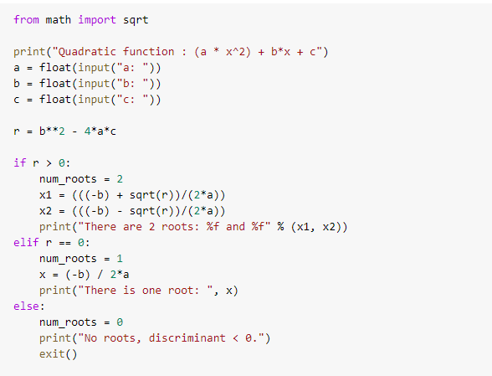

15.Write a python program to find the sum of first ‘n’ natural numbers without using any loop. Ask user to input the value of ‘n’.

